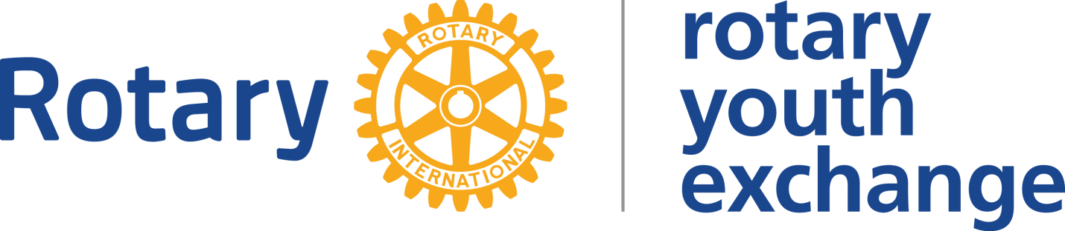
District 5020

STUDENT CONTRACT: 2022-2023
STUDENT: Student Name
SPONSOR: COUNTRY DXXXX HOST: COUNTRY D5020

Rotary Youth Exchange Contract between Student Name and the Club Name Rotary Club

Date: Month – Date - Year

Background:

Note: Provide a general narrative of problems that have been encountered and need to be addressed.

- Problem Identification:

Note: Recap the specific problems

- Expected Behaviour:

Outline how the student will be helped and expected to address the issues noted above

- Timeline:

Outline the timeframe for when resolution is expected

- ..
- ..
- ..

- Potential Consequences for Non-Compliance:

- ..Failure to… will result in…
- ..Failure to… will result in…
- ..Failure to… will result in…

By signing below, you are indicating that you understand all the above and that you have had time to discuss it.

Signed ___________________________________Date _______________________

Witnessed by _____________________________ Date _______________________
(xxxx xxxx – RYE Counselor, xxx Rotary Club)

cc. xxxxxxx (Chairman)
xxxxx xxxxx

xxxx xxxxx (Dxxx RYE sponsor Chairman)
xxxx & ssssss yyyyyy (Parents of Student Name)

